EXPERIMENT-2 -SIMATS Library System

Aim:
To design a cloud-based library book reservation system for managing books and student records.
Procedure:
- Created Books and Students forms to store details.
- A Reservation form was developed using lookup fields to connect students with books.
- Fields like issue date, return date, and status were added.
- Sample data was inserted and reservation process was tested.
- Data was viewed using reports.
Output:
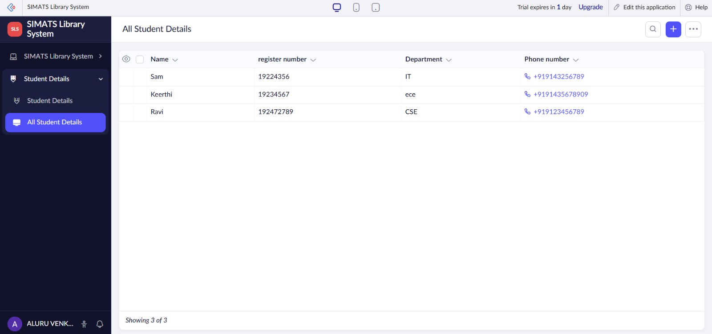

Result:
Library system allows students to reserve books and view records in tabular format.

